SHREE CHANAKYA EDUCATION SOCIETY’S


INDIRA COLLEGE OF ENGINEERING AND MANAGEMENT
Approved By AICTE New Delhi, DTE (MS) and Affiliated to Pune University (Id-No. PU/PN/Engg/282/2007)

Ref. No.: ICEM/Jan2025 Date:02 /09/2025

One Page Report on Kala Avishkar 2025

Date: 15th February 2025
Venue: Near AVIRAT
Time: 6:00 PM Onwards

Detailed Report on Kala Avishkar 2025

The Kala Avishkar 2025 event was organized by Indira College of Engineering and Management, Parandwadi, Pune, on 14th February 2025 at the college campus. The event served as a platform for students to exhibit their creativity, cultural talents, and artistic expressions. It was a celebration of music, dance, art, and fashion, organized under the guidance of Principal Dr. Nilesh Uke and coordinated by Prof. Reshma Kohad, Cultural Coordinator.
The program began at 6:00 PM with a warm welcome address to all dignitaries, faculty members, and students. This was followed by the Lighting of the Lamp Ceremony at 6:05 PM, symbolizing the start of an evening filled with culture, creativity, and celebration. The Principal’s Address at 6:10 PM highlighted the importance of cultural activities in the holistic development of students and appreciated their dedication and enthusiasm.
At 6:15 PM, the Batch Ceremony was conducted, marking the formal farewell to the outgoing students and acknowledging their contribution to the college. The ceremony evoked nostalgia and appreciation, as students shared their heartfelt experiences and gratitude towards the institution.
The Prize Distribution Ceremony began at 6:30 PM, where students were recognized for their outstanding achievements in academics, sports, and extracurricular activities. The awards were presented by the Principal and faculty members, celebrating excellence and dedication.
At 6:50 PM, the stage came alive with a variety of Cultural Performances. Students presented mesmerizing dance performances, melodious singing, and instrumental music that captivated the audience. The dance sequence featured performances by Revti Sonawane, Mugdha Dharmad & Group, Samrudhi Bagwar (Solo), Priyanka Dhale (Solo), Shreya Kakad (Solo), and Vaishnavi Gaikwad & Enosh Pawar. Each act was well-choreographed and showcased creativity and coordination.
In addition to dance, there were musical performances that added a soulful touch to the evening. Rohit Awaghade performed a melodious guitar solo, while Krish Sutar presented a beautiful piano performance that mesmerized the crowd. The audience thoroughly enjoyed these cultural presentations, which reflected the artistic depth of the students.
As the evening progressed, the much-anticipated Ramp Walk began at 8:10 PM, where students from different departments showcased their confidence, elegance, and creativity. The ramp walk featured themes of traditional, western, and fusion wear, displaying the vibrant diversity of Indian fashion.This segment added glamour and excitement to the event, receiving loud applause from the audience.
Finally, the event concluded with the Vote of Thanks at 8:30 PM, delivered by the Cultural Committee. The organizers expressed their gratitude to the management, Principal, faculty members, student coordinators, and participants for making the event a resounding success. Special appreciation was extended to the technical, decoration, and backstage teams for their dedication and seamless execution.
Overall, Kala Avishkar 2025 was a grand celebration of art, culture, and talent. It reflected the spirit of teamwork, creativity, and enthusiasm among students and staff. The event not only provided entertainment but also encouraged students to embrace cultural values and express themselves confidently.
The evening ended on a high note, leaving behind cherished memories of joy, laughter, and togetherness, setting yet another benchmark for future cultural events at Indira College of Engineering and Management.
Few Glimpses from the Event:

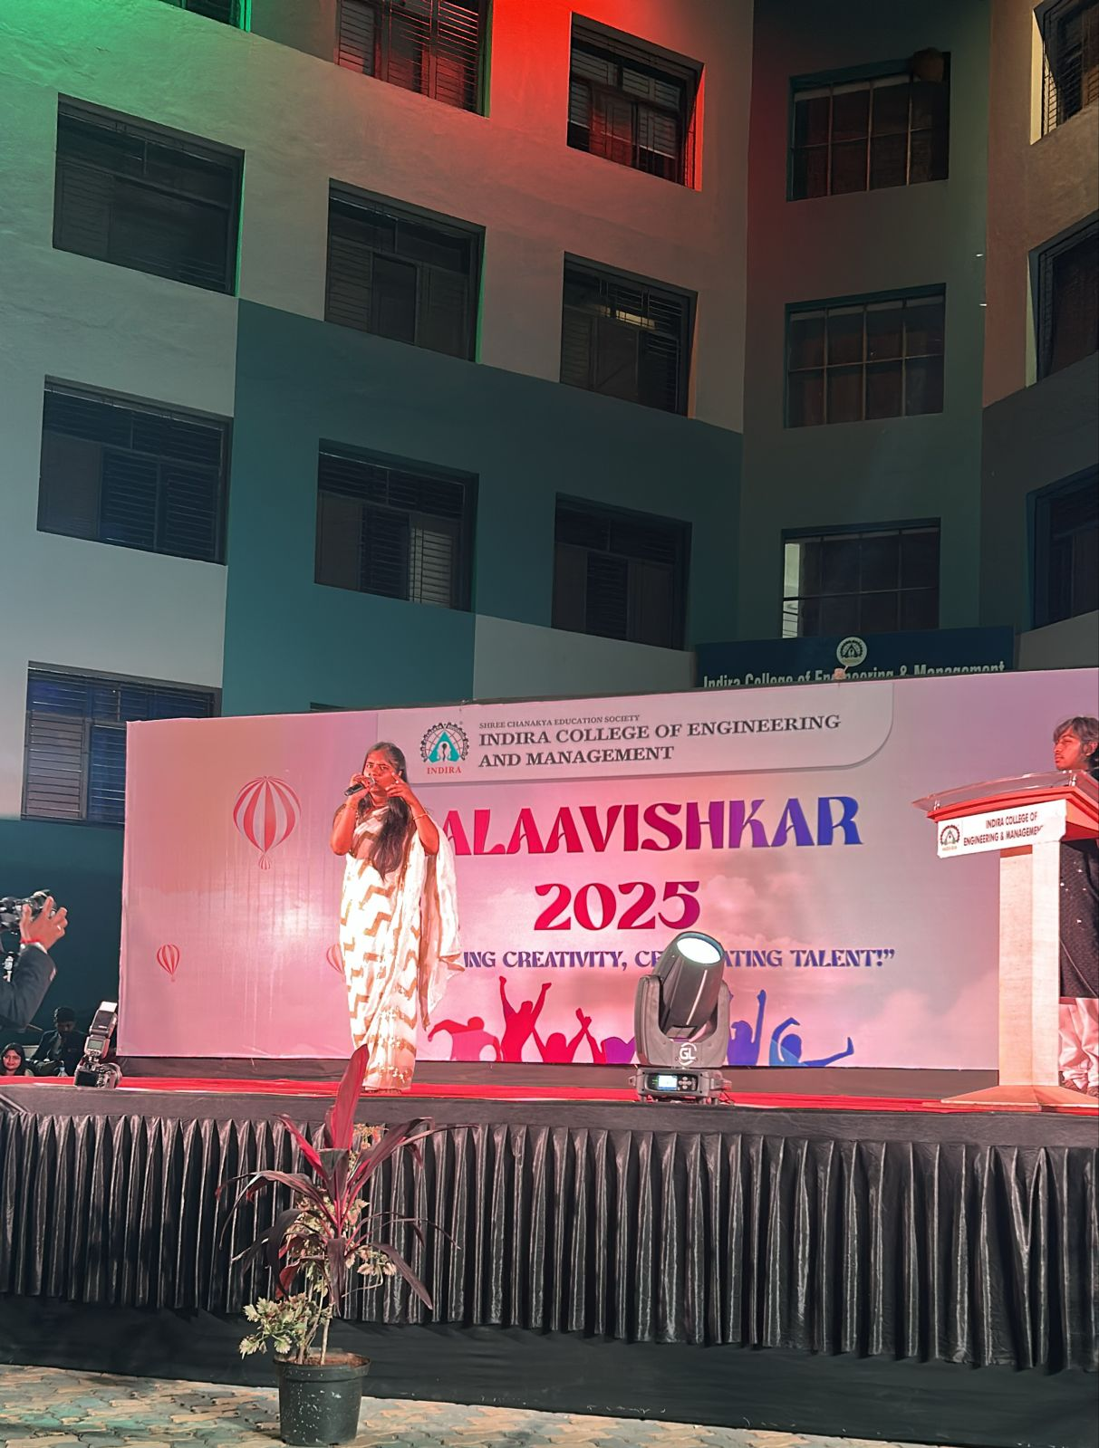

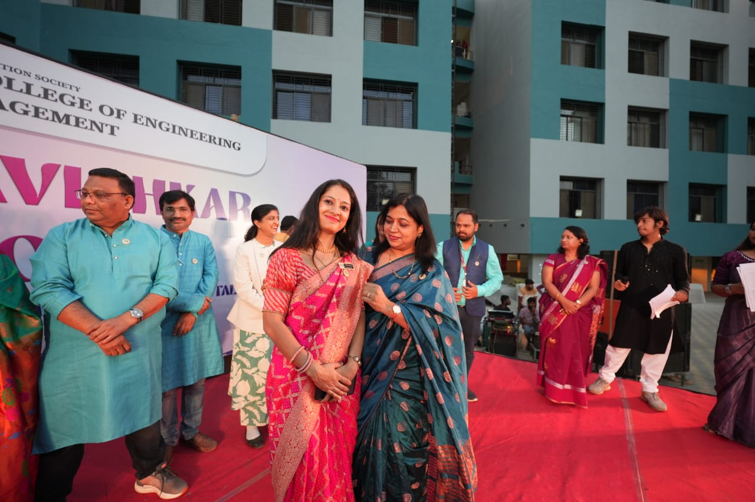

Prof.Reshma Kohad Dr. Nilesh Uke
Cultural Coordinator Principal, ICEM

